News release
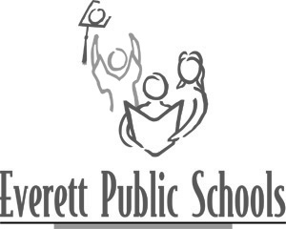
May 14, 2013
For more information:
Mary Waggoner, Director of Communications, 425-385-4040
Kathy Lockwood, Cascade High School German teacher, 425-385-6000

Cascade High School students honored for excellence in German
In the top 90th percentile of the 25,000 students taking the National German Examination

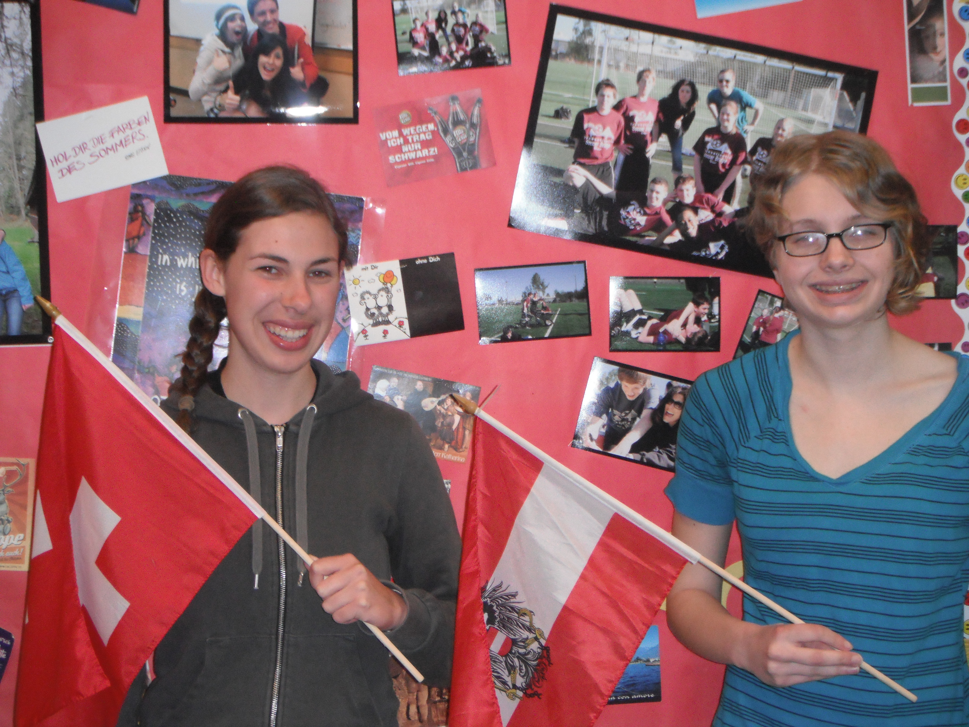
Jessica Holsopple and Briana Lindly are among the top 90th percentile of over 25,000 students who took the National German Examination administered by the American Association of Teachers of German (AATG) in 2013. Only forty-one students in Washington State achieved this level.

“In addition, Briana was submitted to AATG National for consideration of one of thirty-nine study trips awarded nationwide, and we are delighted to report that Briana was selected to receive one of the awards!” announced Kathy Lockwood, German teacher at Cascade.
Jessica Holsopple and Briana Lindly joyfully pose for this recognition!

Briana is headed to Germany in June. Her award includes round-trip airfare from Newark, living with a German family, going to a German school and excursions to places of cultural and historical significance.

Founded in 1926, the AATG is the only national organization representing German teachers at all levels of instruction. The AATG is dedicated to improving teaching of language, literature and culture of the German-speaking countries.

Awards for outstanding students are donated by the German government, Austrian Cultural Forum, Langenscheidt Publishers, and the German Language Opportunities Website (GLOW).

---end---

